Programming Exercise
Questions
For each question, explain your reasoning.
- What is the solution to this error?

SyntaxError: invalid syntax. Maybe you meant '==' or ':=' instead of '='?
- This error usually occurs when you use the assignment operator = inside a conditional statement (if, while, etc.) where Python expects a boolean expression.
Instead we can use the following as a solution:
- == for comparison
- := for assignment expressions
Hence here using ‘==’ would be right solution.

- What was your solution to printing the first 10 Fibonacci numbers?

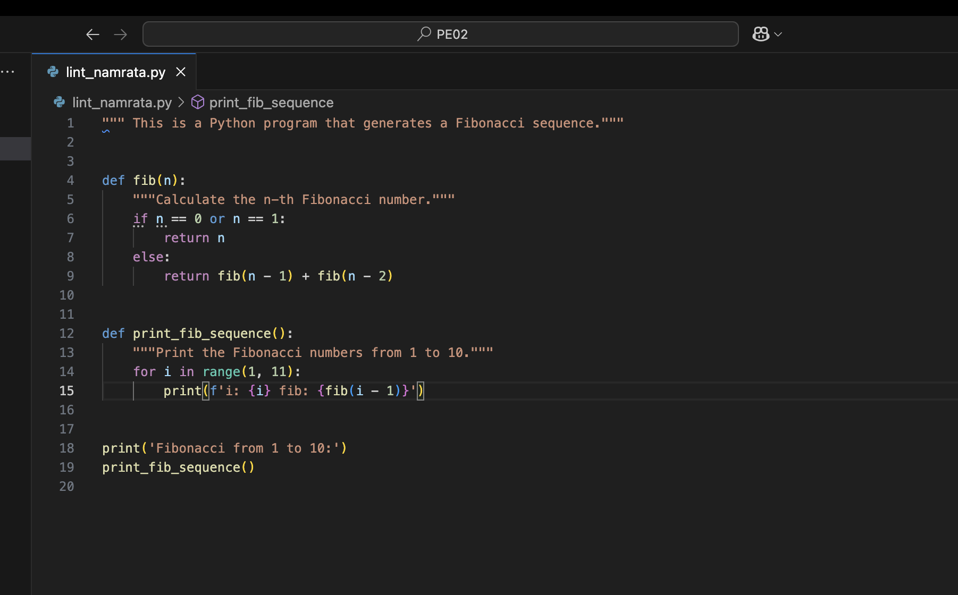
This solution resolves several linting issues:
- Renamed the function to fib to follow snake_case naming style.
- Replaced the module name with a compliant snake_case format.
- Added missing docstrings to both functions.
- Removed trailing whitespace.
- Corrected syntax errors in the conditional and print statement.

- What is the solution to this linting issue?
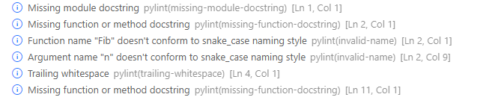
- Rename the function using snake_case instead of CamelCase to follow Python’s PEP8 naming convention.
def fib():
pass

Renaming the function to fib using snake_case aligns with Python’s PEP8 naming convention, improving code readability and consistency. This change enhances maintainability, especially in collaborative environments where standard naming styles are crucial. Following conventions like this also helps avoid linting errors and ensures compatibility with tools that enforce code quality.

